**Forgot password test case**

**Goal:**

As a tester, I want to verify if the Change Email form is working correctly and if the formulary is filled properly.

**Background:**

Forgot password page is responsible to send an link to the user requesting a new password.

**Steps to Reproduce**

1. Go to <https://www.find-a-house.nl/en/home> and click on the menu bar.

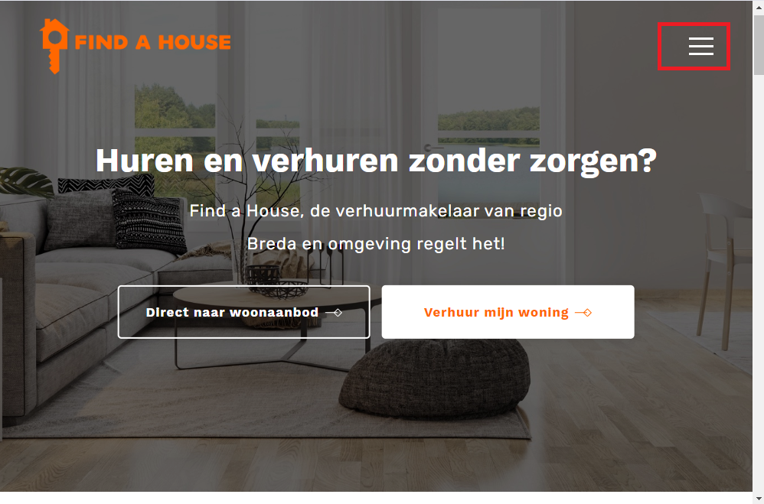

1. Click on the “Inloggen” Button and then open Login page.

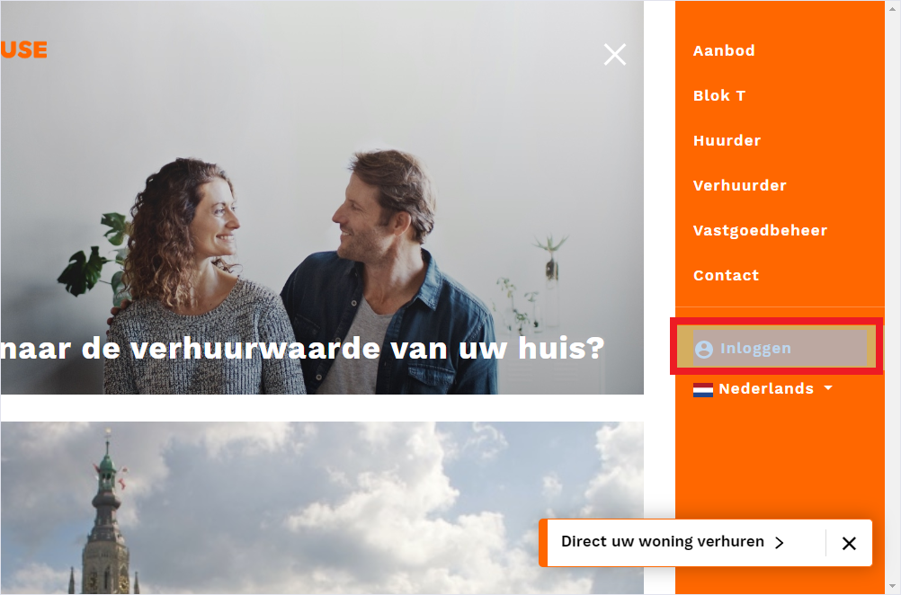

3. Click on the button “Wachtwoord vergeten”.

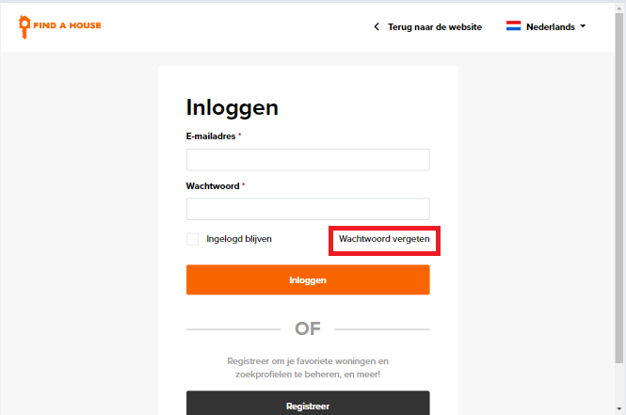

4. Type an email, then click on the button “Wachtwoord opnieuw instellen”.

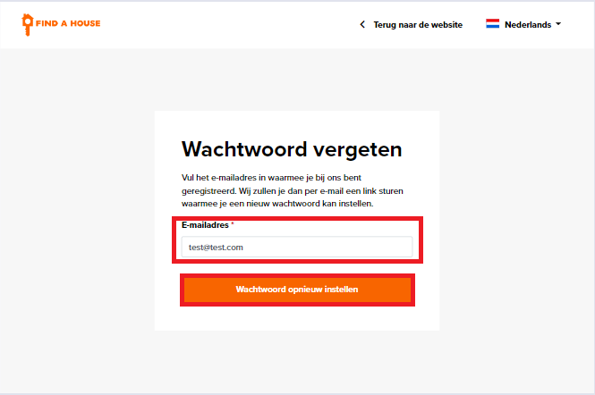

A link will be sent to the user to change the password.

